**SCALING**

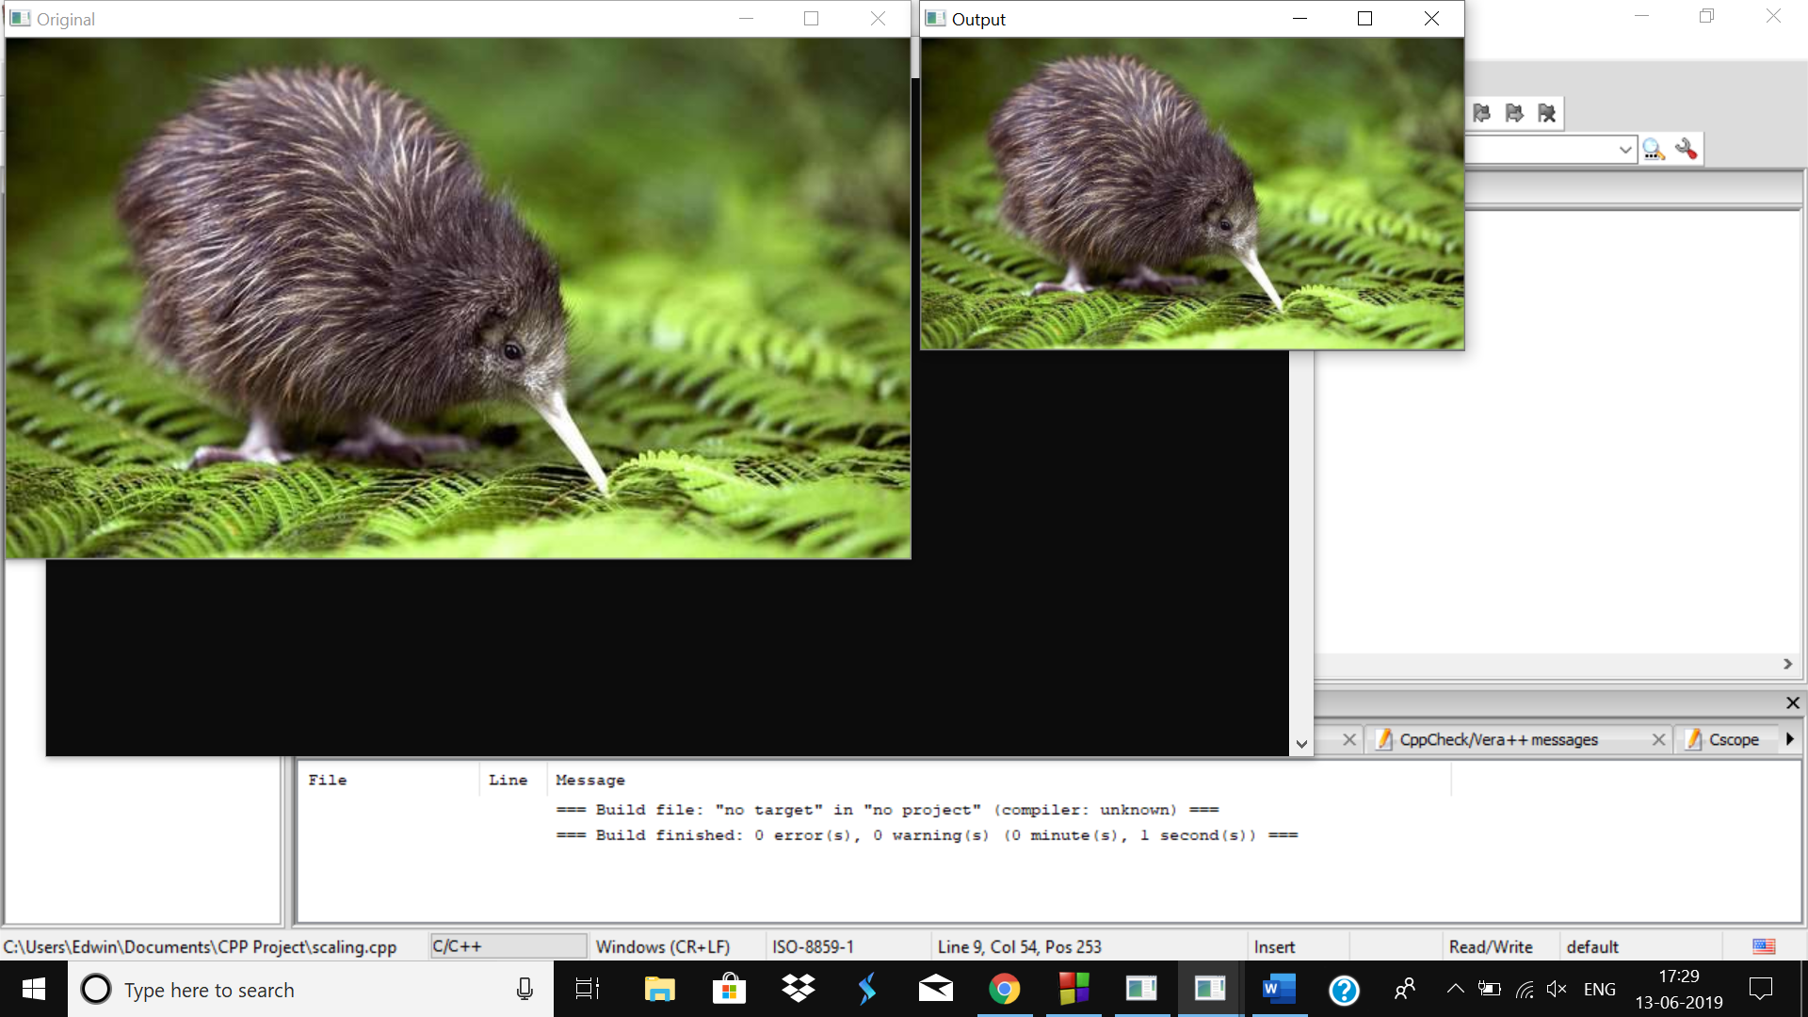

**TRANSLATION**

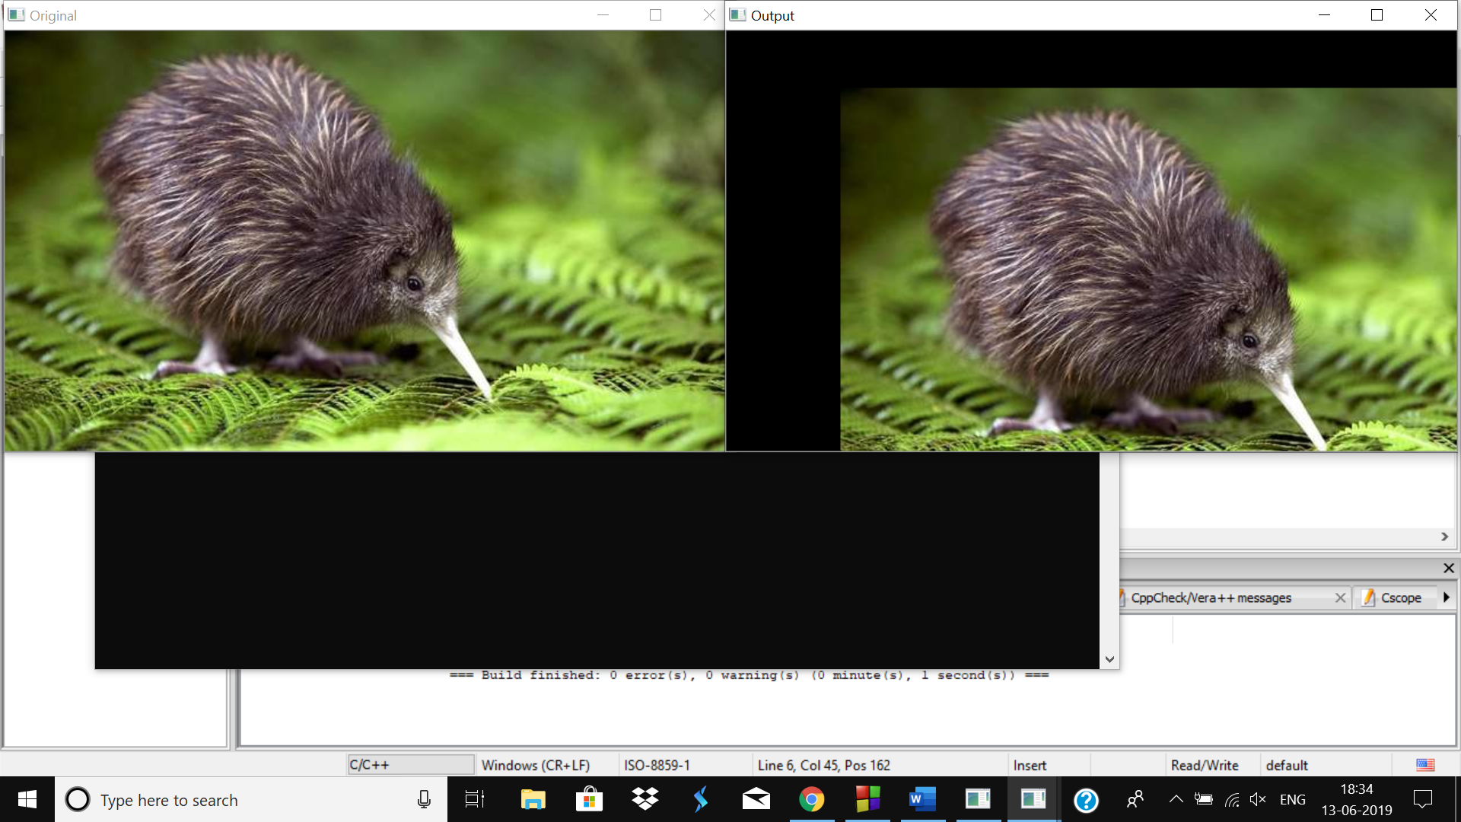

**ROTATION**

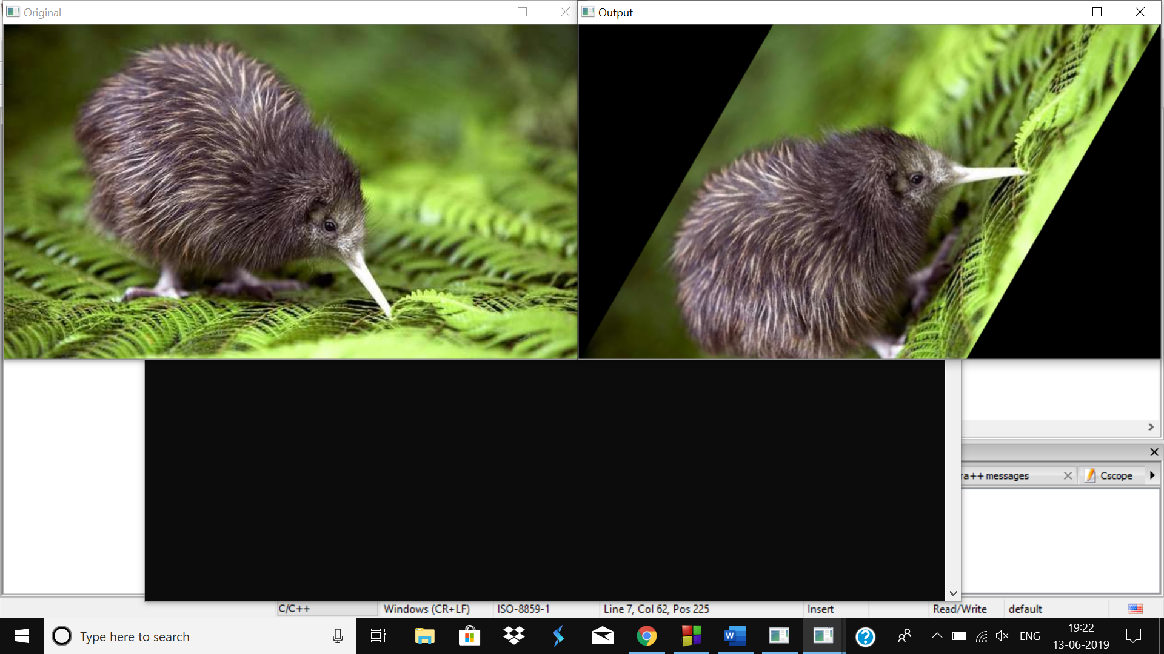

**PERSPECTIVE TRANSFORMATION**

Coordinates taken from persptrack.cpp

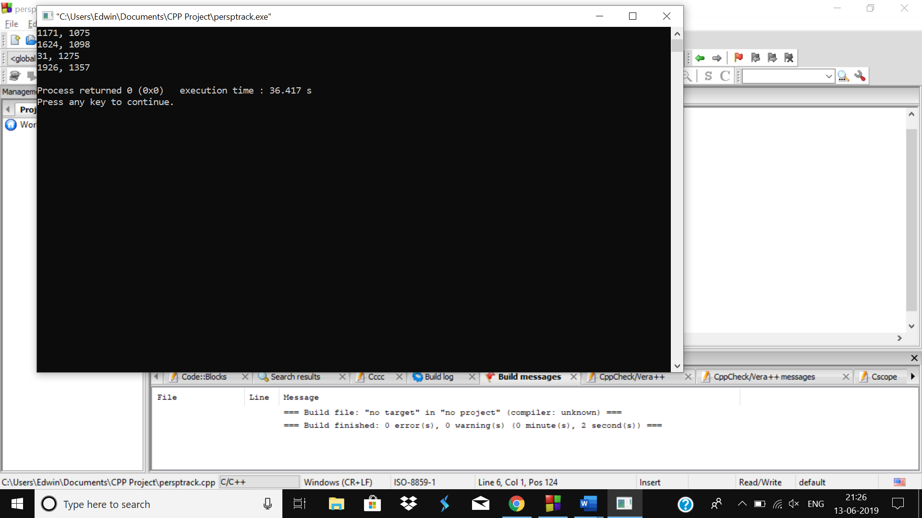

Perspective Transformation performed using above coordinates in perspective.cpp

